LAB 9: Terraform State

Q-1 Which location is the terraform state file stored by default ?
A-1 Inside the configuration directory

Q-2 Which option should we use to disable state?
A-2 We can not disable state

Q-3 Which format is the state file stored in by default?
A-4 JSON

Q-4 Which of the following commands does NOT refresh the state ?
A-4 a. terraform plan b. terraform init c. terraform apply
a. Terraform init – Right

Q-5 What is the name of the state file that is created by default?
A-5 terraform.tfstate

Q-6
Navigate to the configuration directory /root/terraform-projects/project-flash we have created a few configuration files here. The directory has been initialized and the provider plugins downloaded inside the.terraform directory. However, there is no terraform.tfstate file created. Why is that?
A. terraform init was not run correctly
B. terraform plan was not run
C. terraform apply was not run -- Right
D. syntax error

Q-7 Run the terraform show command and identify the id created for the resource called speed_force.
A. 121212-232323
B. 2c23232-23cdc4r23
C. No Deatails Prointed – There is no State – Right
D. 75c434n343-43c9323

Note: Once you created resource by terraform apply , after that, it’s attirbutes created , terraform.tfstate file will created.
Now, you are able to terraform show – show each state of resource.

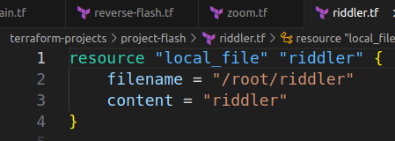
Q-8
Now, run terraform apply in this directory.

Following are configuration files.

A-8 done.
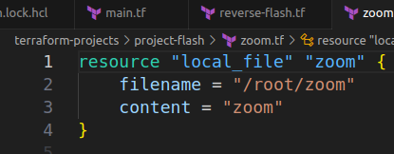
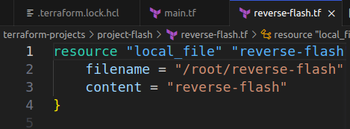

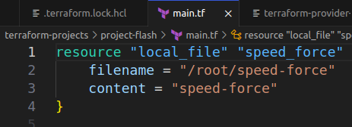

Q-9
Now, check terraform show again. What is the value of id for the resource called speed_force?
A-9 local_file.speed_force: Creation complete after 0s [id=ebeb8b595c8eb4a6e81cacf244146e742fab2981]

Q-10
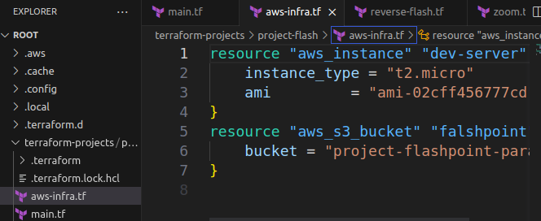
We have just added a new configuration file called aws-infra.tf into this configuration directory and provisioned the resources.
These are AWS resources. Don't worry if they are unfamiliar to you, we will soon be learning about them in the upcoming lectures!
A-10 Done.

